
International Journal for
Electronic Crime Investigation

DOI: https://doi.org/10.54692/ijeci.2026.1002/279

DOI: https://doi.org/10.54692/ijeci.2026.1002/275
ISSN: 2522-3429 (Print)
ISSN: 2616-6003 (Online)

Research Article

Vol. 10 issue 2 Jul-Dec 2026

Cybersecurity Risk in Building Automation Systems on Saudi Arabian Giga Construction Projects: A Risk Governance Framework
Waqar Hussnain¹,*, Mohammad Obeidat², Anood Ali³
¹ ²Abdul Mohsin Al Tamimi Group, Prince Humud Ibn Abdulaziz Street, Al Khobar City, Building No. 6971, Kingdom of Saudi Arabia
³Department of Computer Science, Shaheed Benazir Bhutto Woman University, Peshawar, Pakistan

Corresponding Author: waqarhassan005@gmail.com

Received: September 9,2026 Accepted: September 18,2026 Published: September 26,2026

ABSTRACT
Saudi Arabia’s Vision 2030 giga-projects are connecting building automation systems (BAS) to corporate networks, cloud platforms, and remote vendor access at a rate that has outpaced the cybersecurity governance traditionally applied to operational technology. BAS field protocols such as BACnet, Modbus, and KNX were designed primarily for interoperability rather than operation in adversarial network environments, and legacy deployments often provide limited native authentication and encryption. This paper develops the Building Automation Cybersecurity Risk Framework (BACRF), a six-layer governance model that classifies BAS-specific threats, assigns responsibility across the fragmented delivery chain of owner, project management consultant, contractor, mechanical-electrical-plumbing (MEP) subcontractor, and vendor, and prioritizes mitigation measures through a Cyber-Risk Index (CRI). The framework was built from a structured literature review of 25 sources, screened from an initial pool of database records to a final set spanning industrial control system, cyber-physical systems, and construction cybersecurity literature, together with an illustrative scenario informed by the authors’ professional experience. Applying the CRI to a representative giga-project scenario, with explicitly reported likelihood, consequence, and weighting inputs, identifies network segmentation failure as having the highest priority among unauthorised remote access and supply-chain exposure as the leading risk. The framework provides giga-project owners and delivery teams a reproducible basis suitable for contractual implementation for prioritising BAS cybersecurity investment, although the scoring weights remain illustrative pending calibration against documented incident data.
Keywords: building automation system security; cybersecurity risk governance; industrial control systems; giga-project delivery; cyber-risk index.

1. Introduction

1.1 Background
Saudi Arabia's Vision 2030 initiative has accelerated the adoption of digital project controls and integrated facilities management substantially across the region [1]. In the case of giga-projects such as the tourism destinations in Red Sea Global, NEOM and Qiddiya, building management systems, sensor networks, and remote monitoring are increasingly necessary for the operating cost and guest-experience objectives, as building instrumentation is essential for continuous monitoring [2].
At the heart of this change are building automation systems. A modern BAS interfaces with field controllers and supervisory software and links to corporate networks and vendor support portals, providing control over HVAC systems, lighting systems, life-safety and access-control systems [3]. This paper adopts two terms for the field-and-network control environment—BAS, and BMS—and throughout the paper these two terms are used interchangeably in industry practice, and in the following discussion are treated as synonymous terms. BAS protocols are optimized for interoperability between products from different vendors, and legacy BACnet, Modbus and KNX deployments typically lack built-in authentication and encryption but may provide secure extensions for some product lines [3].
The authors’ professional experience suggests that commissioning practices of Saudi giga-project MEP packages can be attributed to weak authentication and operator practices, which have been identified as significant vulnerabilities in a risk analysis of a deployed smart home platform [4]. However, the intrusion, manipulation of protocols and physical disruption of industrial control systems (ICS) that conventional IT tooling cannot always anticipate also pose practical risks to industrial control system operators [5] and a recent study on BAS security incidents has documented a growing number of incidents related to BAS [6].

1.2 Cybersecurity Risk in the Delivery Chain
Saudi giga-projects are often implemented via a series of distinct organisations rather than by a single responsible operator. The owner engages a project management consultant (PMC), which subsequently engages an engineering-procurement-construction (EPC) or design-and-build (DAB) contractor. This subcontracts MEP packages and the subcontractor in turn sources from a vendor that commissions the BAS and may retain the ability to perform remote access for warranty or support. Every handover can reveal potential gaps in responsibility and accountability, which is one of the main unmet governance gaps identified by a recent construction cybersecurity survey [7].
A review of SCADA security consistently points to governance and process weaknesses rather than solely technical weaknesses as a significant contributing cause of exploitable vulnerabilities [8] and a scoping review of construction cybersecurity research also showed that there is limited research in the sector compared to the sector’s exposure to cybersecurity vulnerabilities [9]. Reported incidents that have resulted in an attack of a building or process network have demonstrated the potential to disrupt life safety systems or pivot into the corporate network [5]. For giga-project hotels or resorts, implications include guest safety, integrity of energy bills, and reputation costs.

1.3 Related Work
The BAS problem is formulated at a higher level of abstraction in the field of Cyber-physical systems research. A survey study of attacks against such systems classifies the attacks as denial of service, false data injection, and man-in-the-middle interception (MITM) [10] which is extended in the next survey to the physical domain, the cyber domain and combined domain attacks [11]. The study indicates that for physical attacks, effective mechanisms are required to detect attacks that have a physical impact and that correlate network-level and process-level information [11]. In a related review, most breaches of industrial cyber-physical systems [12] are attributed to weak boundary protection and undefined policy rather than zero-day vulnerabilities, but a similar observation was made in a previous review, which blamed cloud- and IoT-connected systems for outpacing controls developed for air-gapped systems [13]. A more comprehensive IoT security survey similarly indicates that governance challenges remain insufficiently addressed as well as technical security measures [14].
Another strand focuses on smart buildings with energy efficiency in mind, connected with IoT. One architecture combines the CAP with Datagram Transport Layer Security to demonstrate that security and energy savings can be integrated into the same design [15], and a survey of such applications in building energy management identifies security as one of the primary threats to deployment along with cost and integration complexity [16].
Construction-specific cybersecurity scholarship has grown quickly but remains an emerging field. An industry survey found that about a third of construction firms with a documented cybersecurity plan adopted a general NIST framework without sector-specific adaptation [7]. A study of off-site and modular construction identified further exposure where factory production systems exchange data with site-based control networks [17], a pattern echoed in the prefabricated MEP packages increasingly used on Saudi giga-projects. A machine-learning-based construction cyber risk framework demonstrates that data-driven scoring is feasible, while its authors note that a shortage of documented incident data limits how confidently such models can be calibrated [18], a gap addressed by a companion study that builds a construction cybersecurity literature corpus for topic modelling [19].
Facilities-management research provides an additional perspective. A BIM-enabled facilities management risk matrix finds that the post-occupancy period carries a disproportionate share of documented cyber-attack risk [20], consistent with a study of digital twins in general contracting firms that frames cybersecurity as socio-technical rather than purely technical [21], a view echoed in a recent treatment of smart building cybersecurity as an organisational readiness problem [22]. Zero trust work demonstrates continuous verification being adapted from enterprise IT into operational technology settings [23], and comparable governance-first scoring is applied at municipal scale in smart city risk assessment [24].
Taken together, the reviewed literature explains why BAS protocols are structurally weak, supplies a transferable threat vocabulary, and supports a real governance gap in construction cybersecurity. It does not, however, identify a framework linking BAS-specific threat classes to contractual responsibility across the five-party delivery chain found on Saudi giga-projects, which is the gap examined by this paper.

1.4 Objectives and Contributions
This study develops a conceptual risk governance framework for BAS cybersecurity on Saudi Vision 2030 giga construction projects, with four objectives: review the literature examining the identified governance gap above; classify BAS-specific threat types that are distinct from generic IT risks; build a layered framework linking that classification to contractual responsibility and a quantitative prioritisation method; and assess the framework’s conceptual consistency against recognised ICS standards and a delivery scenario drawn from the authors’ experience. Three contributions follow: a reframing of BAS cybersecurity as a delivery governance question rather than a vendor specification defined after design freeze; a six-class BAS threat taxonomy distinct from generic IT threat models; and BACRF itself, a six-layer framework connecting asset discovery, threat intelligence, risk classification, contractual mapping, prioritisation, and continuous assurance into one governance model for giga-project delivery.

2. Materials and Methods

2.1 Research Design and Practitioner Context
This study adopts a conceptual research approach comprising a literature review using a structured approach and the authors' first-hand professional experience, based on the general guideline for conceptual research [25] that conceptual frameworks should be created from existing theory and practice. This approach is appropriate for addressing a problem that spans multiple domains, such as industrial control system security, cyber-physical systems and construction governance.
The first author is a certified Project Director and has led multiple concurrent packages for Red Sea Global giga-projects. The second author is a Planning Manager with more than 13 years of experience in managing planning, subcontracting, and commissioning risks for MEP and building systems packages for Saudi Aramco, NEOM, Red Sea Global and Qiddiya. The delivery-chain patterns introduced in Sections 1.2 and 3.6 are presented as illustrative examples without being based on empirical evidence, because these observations are derived from professional experience and are consistent with reporting practices of conceptual research based on practitioner insights.

2.2 Literature Search Protocol
Three literature domains were identified: Industrial control and SCADA security, cyber-physical systems security, and construction and smart building cybersecurity governance. The Scopus, Web of Science, IEEE Xplore, ScienceDirect, ACM Digital Library and Oxford Academic databases were searched for the terms including “building automation,” “SCADA,” “cyber-physical systems,” “construction cybersecurity,” “smart building,” and “giga-project” as well as “security,” “risk” and “governance” between January and June 2026.
The initial search identified 164 candidate records. Following duplicate removal and screening of titles and abstracts, 58 records progressed to full text review. If a report included a threat, risk method or governance finding applicable to BAS, ICS or construction delivery, the record was retained, but if it did not refer to control systems, a record was retained if it was relevant to general IT security. This yielded 25 academic sources, 20 of which were published from 2020 to 2026, and five were older foundational studies. A single government policy document, referenced separately, provides contextual information for Vision 2030 and is not included in this count.

2.3 Framework Development and Consistency Check
BACRF was developed as a six-layer framework, each layer building on the previous, ranging from asset visibility to continuous assurance, with content from the source group most closely associated with that layer being used. This reflects the fact that multiple sources address more than one layer, and citations are therefore not assigned exclusively to individual layers. BACRF has not yet been evaluated on an actual project, but rather, it was assessed for internal and external consistency. This check was conducted using three questions: each layer is linked to a research domain; the six threat classes are distinct and encompass the exposure types identified in the review. The assessment also examined whether the contractual mapping is expressed in terms stipulated in a multi-party delivery contract like FIDIC-based or equivalent Saudi bespoke contract form.

3. Results

3.1 Literature Synthesis
Using the search protocol outlined in Section 2.2, 25 academic sources, of which 20 were published between 2020 and 2026 and five of which were foundational, were identified, along with the Vision 2030 policy document. To synthesise the key findings across the eight studies included in the synthesis, Table 1 summarises the focus and key finding for each study and its main contribution to BACRF. Together, these studies support the findings presented in Section 1.3: BAS-specific and cyber-physical systems research provide a technically sound threat vocabulary; facilities-management research identifies handover as a time of high cyber risk; and research in the field of cyber security for construction provides additional evidence of a persistent sector-specific governance gap.

3.2 The BACRF Framework
BACRF is structured as six connected layers moving from asset visibility to continuous assurance. Fig. 1 illustrates how Vision 2030 digitalisation and BAS convergence with corporate IT, combined with legacy protocol weakness and fragmented delivery-chain governance, increase the cyber-attack surface across design, construction, and handover, creating operational, safety, financial, and reputational risks for owners and operators
Fig. 2 presents the resulting six-layer architecture: asset and interface discovery, threat and vulnerability intelligence, risk classification, contractual and governance mapping, risk-informed decision support, and continuous assurance and handover processes

3.2.1 Layer 1: Asset and Interface Discovery
Layer 1 builds an inventory of every BAS and IoT device, switch, controller, and vendor remote-access point, mapped against its protocol, whether BACnet/IP, Modbus, KNX, or a proprietary BMS protocol. On a giga-project this should be developed incrementally as each MEP package is commissioned, because separate vendors often install overlapping network infrastructure on the same site.

3.2.2 Layer 2: Threat and Vulnerability Intelligence
Layer 2 draws on CISA’s ICS advisories, the NIST vulnerability database, and available penetration-test findings to maintain current threat intelligence rather than relying on a single design-stage assessment, consistent with survey findings that scanning and testing remain the two most widely used SCADA assessment methods [8].

3.3 BAS-Specific Threat Taxonomy
Layer 3 classifies each exposure into one of six BAS threat classes, summarised in Table 2, and assigns likelihood and consequence scores using project-context factors rather than sole reliance on generic vulnerability scores. The six classes are drawn from the cyber-physical systems and SCADA literature reviewed in Section 1.3, adapted to a construction and early-operation environment rather than a mature operational asset.
Table 1 Synthesis of Representative Studies Informing the BACRF Layer Architecture
Study | Focus | Key Finding | Contribution to BACRF
Granzer et al. [3] | Protocol-level threat analysis of BACnet and KNX | Authentication and encryption remain limited by design in field-bus protocols | Layers 1–2: asset and protocol inventory
McLaughlin et al. [5] | Review of the ICS cybersecurity landscape | IT-based control systems expand the attack surface as the cyber–physical gap closes | Layer 2: threat intelligence scope
Nazir et al. [8] | Survey of SCADA security assessment techniques | Governance and process gaps, not only technical flaws, contribute to exploitable vulnerabilities | Layers 3–4: risk and governance logic
Cao et al. [10] | Survey of network attacks on cyber-physical systems | Denial of service, false data injection, and MITM represent prominent CPS attack types | Layer 3: threat classification
Kayan et al. [12] | Review of industrial cyber-physical systems security | Weak boundary protection and undefined policy, not zero-days, cause most breaches | Layer 5: governance-first prioritisation
García de Soto et al. [7] | Industry survey on construction cybersecurity | Most construction cybersecurity plans still borrow generic IT frameworks | Supports the identified construction governance gap
Ghadiminia et al. [20] | BIM-FM cyber-attack risk matrix | Post-occupancy carries a disproportionate share of documented cyber risk | Layer 6: assurance at handover
Pärn et al. [21] | Digital twin cybersecurity taxonomy for contracting firms | Digital-twin-enabled construction cybersecurity is socio-technical, not purely technical | Supports the governance-oriented framing of BACRF
Table 2 Six BAS Threat Classes Used by the BACRF Risk Classification Component
Threat Class | Description | Typical Giga-Project Scenario | Primary Source Domain
TC1 Unauthorised remote access | Vendor or integrator remote-access credentials remain active, shared, or unmonitored after commissioning | BAS vendor support account remaining active after handover of a hotel asset months after warranty commissioning | SCADA/ICS security
TC2 Protocol-level manipulation | Exploitation of weak or absent authentication in BACnet, Modbus, or KNX traffic | Unauthenticated write command alters chiller setpoints across a zone | BAS security
TC3 Network segmentation failure | BAS/OT traffic operating on an unsegmented network with corporate IT or another vendor’s system | Fire alarm and guest-room control networks bridged through a common, unmanaged switch | Cyber-physical systems
TC4 Denial of service | Traffic flooding or device resource exhaustion disabling control or monitoring functions | BMS dashboard unavailable during a live safety event due to network congestion | Network attacks on CPS
TC5 Data integrity / false-data injection | Falsified sensor or status data causing incorrect automated or human decisions | Falsified occupancy data inhibits HVAC response in an occupied space | Cyber-physical systems
TC6 Supply-chain / firmware risk | Compromised firmware, counterfeit components, or unpatched known vulnerabilities | Unpatched controller firmware with a published CVE remaining in service two years after handover | ICS vulnerability management

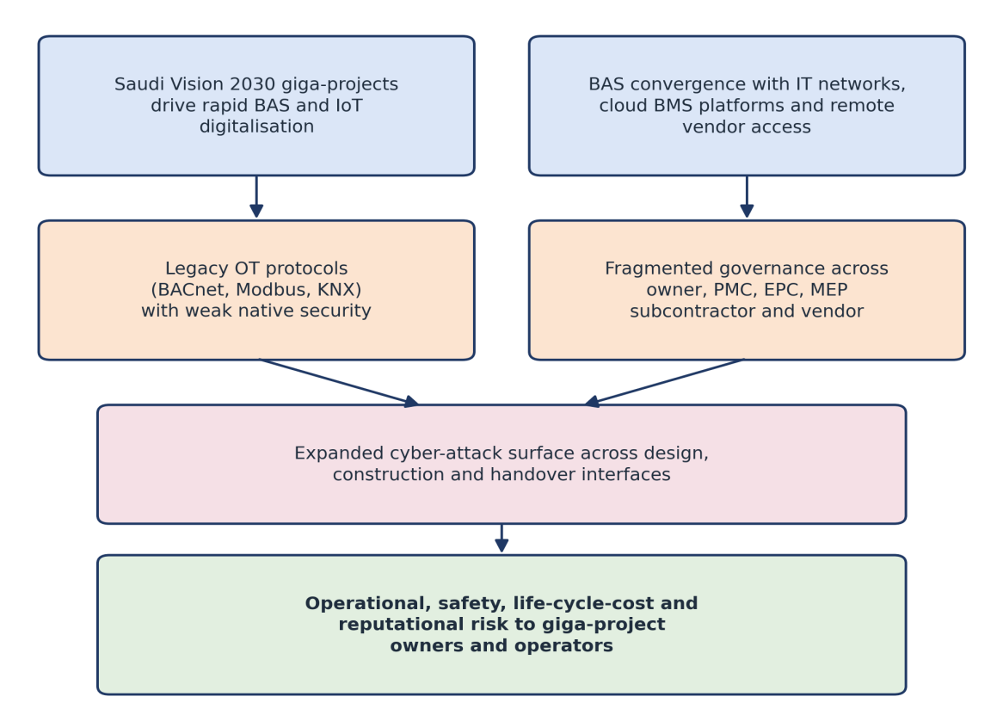
Figure 1 Digitalization Drivers, BAS Exposure Pathways, and Risk Consequences in Saudi Vision 2030 Giga Construction Projects

Table 3 BACRF Layer 4 Responsibility (RACI) Matrix Across the Five-Party Delivery Chain
Threat Class | Owner | PMC | EPC/D&B | MEP Sub. | BAS Vendor
TC1 Unauthorised remote access | I | A | C | R | R
TC2 Protocol-level manipulation | I | C | C | R | A
TC3 Network segmentation failure | A | R | R | C | I
TC4 Denial of service | I | A | R | R | C
TC5 Data integrity / false-data injection | I | C | C | A | R
TC6 Supply-chain / firmware risk | A | C | I | C | R
R = Responsible (executes mitigation); A = Accountable (owns sign-off); C = Consulted (subject-matter input); I = Informed (kept updated).

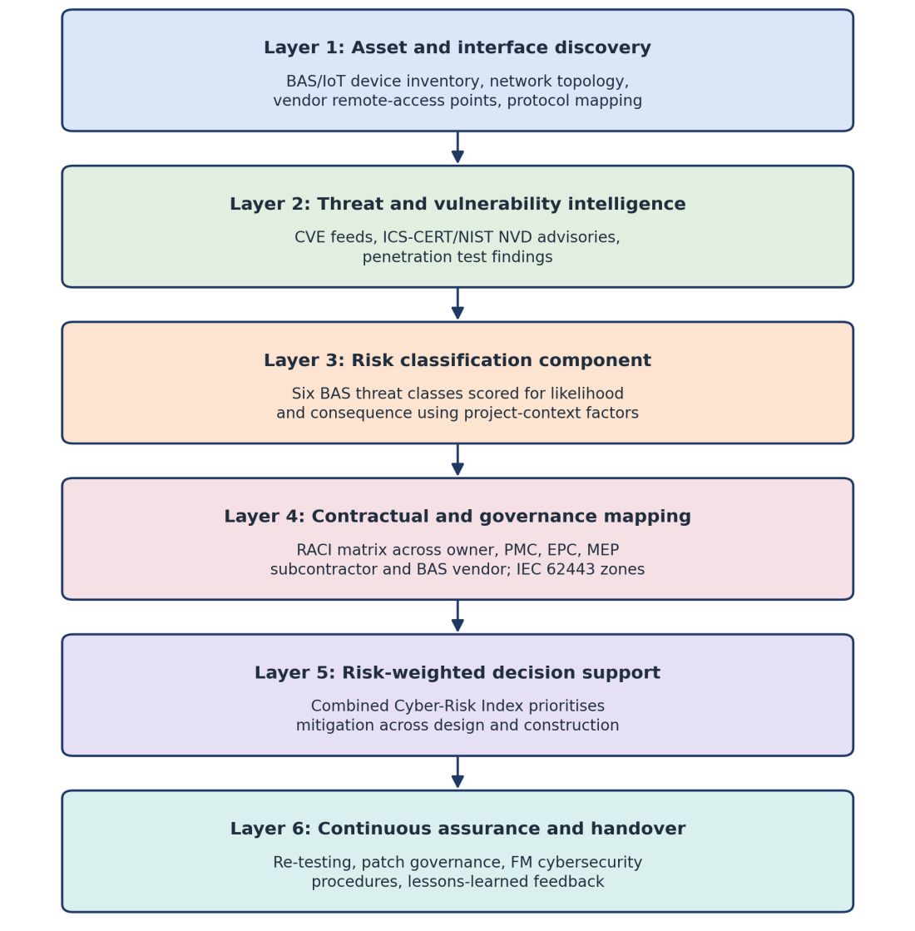
Figure 2 The Building Automation Cybersecurity Risk Framework (BACRF): Six-Layer Architecture

The Cyber-Risk Index for a given asset or interface integrates likelihood and consequence across the six classes:
CRI = Σᵢ (Lᵢ × Cᵢ × Wᵢ)
Here Lᵢ is the likelihood of threat class i, scored on a scale of 1–5 using factors such as the number of external remote-access points and the age of installed firmware. Cᵢ is the consequence, scored on a scale of 1–5 against safety, operational, and reputational impact. Wᵢ is a weighting coefficient reflecting the priority assigned by the project to each class, normalised so the six weights sum to one. Because L and C are each bounded by five, the maximum possible total CRI is twenty-five; Section 3.7 applies this formulation to an illustrative example with fully disclosed inputs.

3.4 Layer 4: Contractual and Governance Mapping
Layer 4 builds on ICS literature that typically assumes a single operating entity and maps each classified risk to the party responsible for mitigation. The mapping is based on the IEC 62443 zone and conduit concept, where a control network for a facility is segmented into security zones with defined and controlled conduits [26]. Table 3 describes this in terms of responsibility, accountability, consultation, and information (RACI) matrix among the five delivery parties. Each class has exactly one Accountable party with final sign-off as per the normal RACI, but multiple parties may be Responsible for related activities. For a giga-project, each subcontractor of the MEP should specify in its scope the zone where the equipment is installed, and which party is responsible for segmentation. When this is not present, it is a recurring issue observed by the authors in their professional experience that should be addressed in the award process. The mapping is conceptually aligned with a multi-party contractual structure that could be FIDIC based or any other Saudi-specific contract forms (to be tested in subcontract drafting).

3.5 Layers 5 and 6: Decision Support and Continuous Assurance
Layer 5 prioritises mitigation using a combination of the CRI from layer 3 and mapping from layer 4. This helps to prioritize exposures so that a team can allocate a finite cybersecurity budget for the highest-scoring exposure and provide justification based on a score rather than relying solely on qualitative judgment. It also maintains a correlation of each flagged risk with the advisory, segmentation gap, or even a silent contractual clause that supports its prioritisation, which enables reviewers to assess the rationale for a risk ranking.
Layer 6 addresses the transition from practical completion to early operation, during which a giga-project asset shifts from the EPC contractor to the facilities-management owner, as described in the literature as a period during which a substantial proportion of documented cyber risk is transferred [20]. It is specific about periodic re-testing; patch governance for BAS firmware; cyber security protocols for the new facilities team; and a lessons-learned mechanism improving the Layer 3 weights for future projects.

3.6 Application Scenario
The following scenario illustrates how BACRF applies to a delivery configuration observed in Saudi giga-project MEP delivery. It is offered to demonstrate the framework’s logic rather than as a documented incident. A resort hotel’s mechanical subcontractor commissions a chiller plant controller on a Modbus network, while a separate vendor commissions guest-room controls on a KNX network. Both networks share the same site-wide structured cabling backbone, installed under a general builders’ work package without a documented segmentation design.
Under Layer 1, asset discovery records both networks and their dependency on the shared backbone at commissioning. Under Layer 3, the classification component classifies this as a network segmentation failure, since neither network has a defined conduit boundary from the corporate guest Wi-Fi sharing the same backbone. Under Layer 4, contractual mapping indicates that neither subcontractor’s scope assigns responsibility for the shared backbone, a gap requiring resolution before the defects liability period expires.

3.7 Illustrative Cyber-Risk Index Scoring
Table 4 presents illustrative likelihood, consequence, and weight values for each threat class in the scenario described above, with the resulting raw contribution (L×C×W) and a priority score obtained by scaling each contribution against the highest-scoring class to a common zero-to-ten range. The six weights sum to one, and the six raw contributions sum to a total CRI of 11.9 out of the maximum of 25 defined in Section 3.3.
Table 4 Likelihood, Consequence, and Weight Inputs Underlying Figure 3 (Sum of W = 1.00; Total CRI = 11.9 of 25)
Threat Class | L (1–5) | C (1–5) | W | L×C×W | Priority Score (0–10)
TC1 Unauthorised remote access | 4 | 3 | 0.20 | 2.40 | 4.8
TC2 Protocol-level manipulation | 3 | 3 | 0.15 | 1.35 | 2.7
TC3 Network segmentation failure | 5 | 4 | 0.25 | 5.00 | 10.0
TC4 Denial of service | 2 | 4 | 0.15 | 1.20 | 2.4
TC5 Data integrity / false-data injection | 2 | 3 | 0.10 | 0.60 | 1.2
TC6 Supply-chain / firmware risk | 3 | 3 | 0.15 | 1.35 | 2.7

Fig. 3 plots the priority scores from Table 4. Network segmentation failure produces the highest score, reflecting both the likelihood of an undocumented shared backbone on a multi-vendor MEP package and the consequence of a breach with the potential to propagate from guest-room controls into life-safety or corporate systems. Data integrity and false-data injection produce the lowest score, because no falsified-sensor pathway has been identified on the shared network
Under Layer 5, these results could inform the sequencing of remedial segmentation work, whether commissioned before or after handover; under Layer 6, the outcome would be recorded to inform segmentation clauses in later subcontracts. Empirical testing of these weights against actual project data remains a task for future research, discussed in Section 4.3.

3.8 Conceptual Consistency Assessment
The framework is logically consistent with the three checks outlined in Section 2.3. Each layer is related to an established research domain, and the six threat classes listed in Table 2 are distinguishable and represent major types of exposures mentioned in the literature. The Layer 4 mapping in Table 3 is also expressed through contractual terms, scopes of work, zones, and conduits, which are conceptually compatible with bespoke contractual structures in Saudi Arabia, such as FIDIC.
The numerical weights, however, are not calibrated, and the scoring in Table 4 and Fig. 3 has not been validated against a documented set of BAS security incidents. The authors were not able to find any publicly available dataset of this nature for Saudi giga-projects..
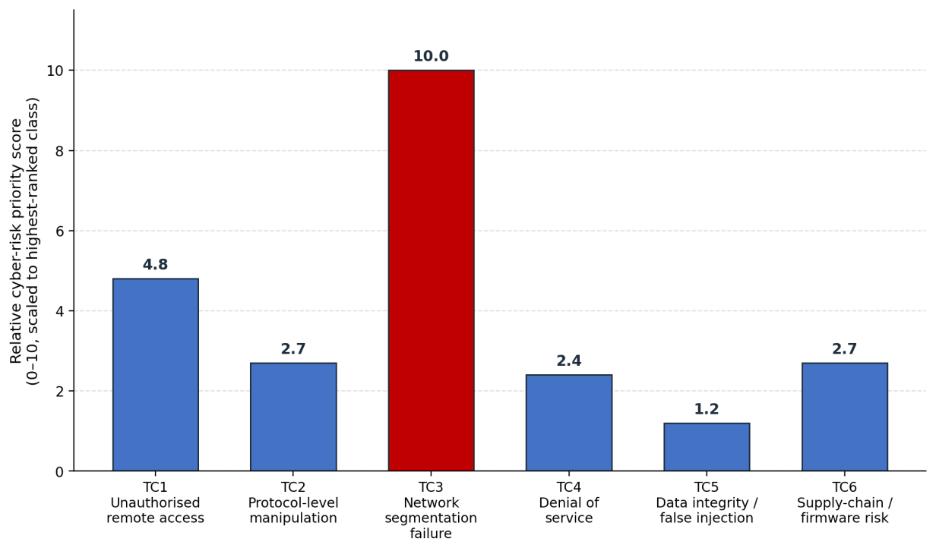
Figure 3 Relative Cyber-Risk Priority Scores Across the Six BAS Threat Classes for the Application Scenario

4. DISCUSSION

4.1 Novelty Relative to Existing Practice
The principal contribution of BACRF is to treat BAS cybersecurity as a function of contractual responsibility at each delivery stage, rather than as a fixed technical specification provided to a vendor at design freeze. Existing ICS and SCADA frameworks assume a single accountable operator managing an already-operating asset [5, 8]. This does not reflect a chain of owner, PMC, contractor, MEP subcontractor, and vendor, each assuming responsibility for different components of the delivery process for a limited period. The reviewed literature did not identify a framework linking BAS-specific threat classes to contractual responsibility across this five-party structure. BACRF extends existing BIM-facilities-management and digital-twin work in the construction cybersecurity literature [20, 21] by focusing on building automation networks specifically.

4.2 Practical Implications
For project directors and PMC teams, BACRF provides a structured basis for allocating a cybersecurity budget allocation across a multi-package MEP scope, using the Cyber-Risk Index in Table 4 to justify prioritisation rather than a uniform allocation irrespective of exposure. For commercial teams, the mapping in Table 3 provides a template for incorporating cybersecurity and patch-management obligations into MEP and BAS subcontracts before award.
For facilities-management teams assuming responsibility for a completed asset, Layer 6 provides a defined basis for cybersecurity procedures at handover, addressing the elevated post-occupancy risk documented in the facilities-management literature [20]. These implications depend on data quality, since the framework depends on the quality of the asset inventory feeding Layer 1 and the contractual clarity achieved in Layer 4.

4.3 Limitations and Future Work
This study has three principal limitations. BACRF has not yet been evaluated on a live project, and has not been empirically validated against actual results. The probability, consequence, and weighting values presented in Table 4 have not been empirically calibrated, as the authors were not able to find a public dataset of security incidents to BAS-specific to Saudi giga-projects. The six threat classes have not been tested against a systematically gathered corpus of actual incidents to assess their comprehensiveness for all delivery circumstances.
Future research should focus on a structured incident review in collaboration with participating owner/PMC organisations to provide anonymised data, a pilot evaluation of the Layer 4 mapping on a current MEP package and an expert elicitation study (a Delphi process with practitioners from the Saudi giga-project field to test the validity of the six classes and the CRI weights against their practitioners’ perceptions of relative risk levels).

5. CONCLUSION
In this paper, this study proposes the Building Automation Cybersecurity Risk Framework, a framework for governing BAS cybersecurity risk in the complex delivery environments characteristic of Saudi Vision 2030 giga construction projects. The framework categorises BAS-specific threats as presented in Table 2, and maps these threats across the five-party delivery chain in the matrix in Table 3, and prioritises mitigation with the Cyber-Risk Index presented in Table 4 and Fig. 3. This does not replace specialist testing and advice undertaken at Layers 2 and 6 but can inform governance decisions.
Its main contribution is the shift in focus of BAS cyber security from a vendor-specific specification to a delivery governance issue. The scoring weights are tentative until they are validated against actual incidents and the next step is to evaluate the framework in an operational project environment to assess its utility for managing a risk category that may remain under-prioritized in procurement practice.

REFERENCES
[1] Kingdom of Saudi Arabia, “Vision 2030,” Riyadh, Saudi Arabia, 2016. [Online]. Available: https://www.vision2030.gov.sa/
[2] I. Bahreldin, H. Samir, R. Maddah, H. Hammad, and I. Hegazy, “Leveraging advanced digital technologies for smart city development in Saudi Arabia: Opportunities, challenges, and strategic pathways,” Int. J. Low-Carbon Technol., vol. 20, pp. 834–847, 2025, doi: 10.1093/ijlct/ctaf044.
[3] W. Granzer, F. Praus, and W. Kastner, “Security in building automation systems,” IEEE Trans. Ind. Electron., vol. 57, no. 11, pp. 3622–3630, 2010, doi: 10.1109/TIE.2009.2036033.
[4] A. Jacobsson, M. Boldt, and B. Carlsson, “A risk analysis of a smart home automation system,” Future Gener. Comput. Syst., vol. 56, pp. 719–733, 2016, doi: 10.1016/j.future.2015.09.003.
[5] S. McLaughlin, C. Konstantinou, X. Wang, L. Davi, A.-R. Sadeghi, M. Maniatakos, and R. Karri, “The cybersecurity landscape in industrial control systems,” Proc. IEEE, vol. 104, no. 5, pp. 1039–1057, 2016, doi: 10.1109/JPROC.2015.2512235.
[6] G. Li, Z. Yang, Y. Fu, L. Ren, J. Wu, Q. Zhu, T. Wu, K. S. Candan, and Z. O’Neill, “A critical review of cyber-physical security for building automation systems,” Annu. Rev. Control, vol. 55, pp. 237–254, 2023, doi: 10.1016/j.arcontrol.2023.02.004.
[7] B. García de Soto, Ž. Turk, A. Maciel, B. Mantha, A. Georgescu, and M. S. Sonkor, “Understanding the significance of cybersecurity in the construction industry: Survey findings,” J. Constr. Eng. Manage., vol. 148, no. 9, Art. no. 04022095, 2022, doi: 10.1061/(ASCE)CO.1943-7862.0002344.
[8] S. Nazir, S. Patel, and D. Patel, “Assessing and augmenting SCADA cyber security: A survey of techniques,” Comput. Secur., vol. 70, pp. 436–454, 2017, doi: 10.1016/j.cose.2017.06.010.
[9] N. S. Pargoo and M. Ilbeigi, “A scoping review for cybersecurity in the construction industry,” J. Manage. Eng., vol. 39, no. 2, 2023, doi: 10.1061/JMENEA.MEENG-5034.
[10] L. Cao, X. Jiang, Y. Zhao, S. Wang, D. You, and X. Xu, “A survey of network attacks on cyber-physical systems,” IEEE Access, vol. 8, pp. 44219–44227, 2020, doi: 10.1109/ACCESS.2020.2977423.
[11] Z. Yu et al., “A survey on cyber-physical systems security,” IEEE Internet Things J., vol. 10, no. 24, pp. 21670–21686, 2023, doi: 10.1109/JIOT.2023.3289625.
[12] H. Kayan, M. Nunes, O. Rana, P. Burnap, and C. Perera, “Cybersecurity of industrial cyber-physical systems: A review,” ACM Comput. Surv., vol. 54, no. 11, pp. 1–35, 2022, doi: 10.1145/3510410.
[13] G. Yadav and A. Paul, “Architecture and security of SCADA systems: A review,” Int. J. Crit. Infrastruct. Prot., vol. 34, Art. no. 100433, 2021, doi: 10.1016/j.ijcip.2021.100433.
[14] A. E. Omolara, A. Alabdulatif, O. I. Abiodun, M. Alawida, A. Alabdulatif, and H. Arshad, “The internet of things security: A survey encompassing unexplored areas and new insights,” Comput. Secur., vol. 112, Art. no. 102494, 2022, doi: 10.1016/j.cose.2021.102494.
[15] A. K. Kumar et al., “Secure and energy-efficient smart building architecture with emerging technology IoT,” Comput. Commun., vol. 176, pp. 207–217, 2021, doi: 10.1016/j.comcom.2021.06.003.
[16] M. Poyyamozhi et al., “IoT—a promising solution to energy management in smart buildings: A systematic review, applications, barriers, and future scope,” Buildings, vol. 14, no. 11, Art. no. 3446, 2024, doi: 10.3390/buildings14113446.
[17] K. Nyamuchiwa, Z. Lei, and C. Aranas, “Cybersecurity vulnerabilities in off-site construction,” Appl. Sci., vol. 12, no. 10, Art. no. 5037, 2022, doi: 10.3390/app12105037.
[18] D. Yao and B. García de Soto, “Cyber risk assessment framework for the construction industry using machine learning techniques,” Buildings, vol. 14, no. 6, Art. no. 1561, 2024, doi: 10.3390/buildings14061561.
[19] D. Yao and B. García de Soto, “A corpus database for cybersecurity topic modeling in the construction industry,” in Proc. 40th Int. Symp. Autom. Robot. Constr. (ISARC), 2023, pp. 537–544, doi: 10.22260/ISARC2023/0072.
[20] N. Ghadiminia, M. Mayouf, S. Cox, and J. Krasniewicz, “BIM-enabled facilities management (FM): A scrutiny of risks resulting from cyber attacks,” J. Facil. Manage., vol. 20, no. 3, pp. 326–349, 2022, doi: 10.1108/JFM-01-2021-0001.
[21] E. Pärn, N. Ghadiminia, B. García de Soto, and K. Oti-Sarpong, “A perfect storm: Digital twins, cybersecurity, and general contracting firms,” Dev. Built Environ., vol. 18, Art. no. 100466, 2024, doi: 10.1016/j.dibe.2024.100466.
[22] Z. Pourzolfaghar, A. Habibi Lashkari, R. Hashemi, and M. Helfert, “Cybersecurity challenges for smart buildings,” in Understanding Cybersecurity Management in the Construction Industry, Progress in IS. Cham, Switzerland: Springer, 2026, doi: 10.1007/978-3-032-13304-5_5.
[23] N. F. Syed, S. W. Shah, A. Shaghaghi, A. Anwar, Z. Baig, and R. Doss, “Zero trust architecture (ZTA): A comprehensive survey,” IEEE Access, vol. 10, pp. 57143–57179, 2022, doi: 10.1109/ACCESS.2022.3174679.
[24] M. Kalinin, V. Krundyshev, and P. Zegzhda, “Cybersecurity risk assessment in smart city infrastructures,” Machines, vol. 9, no. 4, Art. no. 78, 2021, doi: 10.3390/machines9040078.
[25] Y. Jabareen, “Building a conceptual framework: Philosophy, definitions, and procedure,” Int. J. Qual. Methods, vol. 8, no. 4, pp. 49–62, 2009, doi: 10.1177/160940690900800406.
[26] International Electrotechnical Commission, IEC 62443-2-1:2024—Security Program Requirements for IACS Asset Owners. Geneva, Switzerland: IEC, 2024.

